Shaping the FINAL FRONTIER

The future of orbital satellites

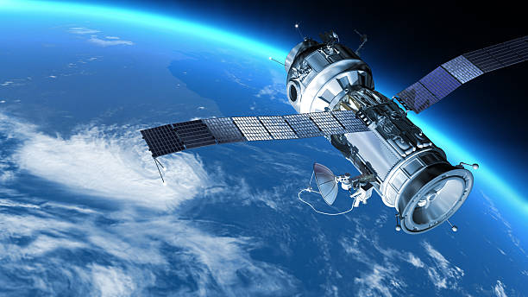

Wiley Jones B.S. Computer Science

[jonewile@oregonstate.edu](mailto:jonewile@oregonstate.edu)

CS 332

TAble of  
Contents

INTRODUCTION 1

Topic Information 1

Questions 2

Data Gathering 4

DataSet 1 – UCS Sateliite DataBase 4

Dataset 2 – NextSpaceflight: Mission launches 5

References 6

# INTRODUCTION

## Topic Information

Whether it’s cutting-edge research into the depths of space or enabling the internet so you can look up the best burrito place on your cell phone, almost every facet of modern life is dependent on satellites and the technology they enable. The rise of orbital satellites has gone hand in hand with the advancements of the 20th and 21st centuries, and there is no sign of that trend slowing down. In fact, the space and satellite industries are only growing larger and more integrated into society with the rise of civilian companies in the industry. Therefore, a thorough understanding of the satellite market is needed to allow government and business interests to make the best decisions on continued launches of satellites into orbit.

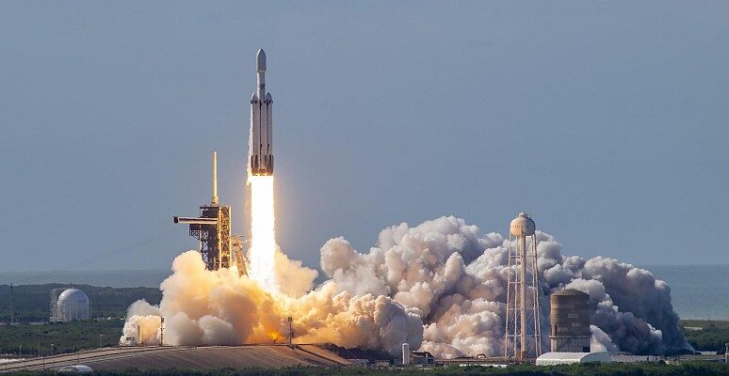As this growth continues, this report seeks to answer those fundamental questions about the present and future of satellites. There are currently over six thousand active satellites in orbit—all in various capacities, sizes, lifespans, and costs. I aim to illustrate the recent advances in the industry and illuminate where it is going in the future. These marvels of modern engineering are the backbone of the technological world and discovering the trends in the spread of these machines will reveal what we can expect from the world of tomorrow. As the planet continues to blast its destiny out of the atmosphere the potential for business and market growth is out of this world.

Nasa Launches GOES-U Satellite

I chose this topic because I believe that people are unaware of the impact that satellite technology has on their daily lives and the future of the world. As the number of launches only increases, I believe that developing an understanding of the industry is paramount to shaping a future where satellite technology is utilized to its greatest effect. It might be the difference in whether humanity’s meteoric economic and technological rise continues or fizzles out.

## Questions

What is the expected rate of growth in satellite launches? And when would the theoretical limit for low earth orbit be met?

* I would track the rate of increase in launches and project that into the future with the machine learning model. Then I would check that against the suspected limit of orbits possible.

How has the utility of satellites changed over time and what trends to expect in the future?

* Track the different uses of satellites over time and see what industries are expanding the fastest. Use the machine model to predict if the expansion is increasing or slowing for each industry.

What industry contractors are unserved and prime for expansion?

* See what industries are already heavily involved in the satellite space, and then map the companies or contractors in that space that have the least foothold. Could use some of the other answers to make suggestions on how to scale for them.

How will the costs of a satellite launch change in the future?

* Map the cost of satellites over time (might have to adjust for inflation) and forecast the future of prices. Would use the machine learning linear regression to make a ballpark prediction of the upcoming costs.

How has the weight of satellites changed and what are they projected to be in the future?

* Track the change of weights in satellites over time and forecast where it will go in the future. This would give insight into the future of the industry to see if more massive satellites are becoming viable with the costs.

How has the life expectancy of satellites changed and what will they be in the future?

* Track the life of active and retired satellites and use the machine learning model to find if there is a pattern in the longevity of the spacecraft.

Which countries will have the fastest-growing satellite networks? And who are the major players of tomorrow?

* Track the number of launches from various countries around the globe and see where the most growth is occurring. Use the machine learning model to predict expansion patterns for countries. Maybe cross-reference these trends with economic data to see how they correlate.

What launching stations will see the most growth?

* Track the number of launches from various sites and figure out how the numbers have changed. Uses this data to find what sites have the capacity for more launches based on the current rate of expansion.

What time of year is best for launches? And what areas in the world have the best conditions?

* Use the data to track the launch dates of various rockets and compare that to average weather data from the area. Cross-reference this with other areas with similar weather to see where new sites could be built.

Which orbits serve what industries better and what has room for growth?

* Document satellite uses in the different levels of orbit and see which industries are using what orbits. If an industry is using multiple orbits, predict if others in the industry should move to a different orbit with less competition for space.

# Data Gathering

## DataSet 1 – UCS SateliTte DataBase

The first dataset gathered was the UCS (Union of Concerned Scientists) Satellite Database. It is a comprehensive list of all the active satellites in orbit with data with technical specs of the spacecraft and information on the use, industry, company, and country of origin. It is a labeled CSV file dataset with both quantitative and qualitative data.

Link: <https://www.ucsusa.org/resources/satellite-database>

**Quantitative Data Labels**

Longitude of GEO, Perigee, Apogee, Eccentricity, Inclination in degrees, Period, Launch Mass, Dry Mass, Power, Launch Date, Expected Lifetime, COSPAR number, and NORAD Number

**Qualitative Data Labels**

Name of Satellite, Current Official Name, Country of UN Registry, Owner/Operator, Users, Purpose, Detailed Purpose, Class of Orbit, Type of Orbit, Contractor, Country of Contractor, Launch Site, and Launch Vehicle

## Dataset 2 – NextSpaceflight: Mission launches

This is a dataset compiled on Kaggle but pulled from the website spaceflightnow.com. It is a list of all launches into space, satellite or manned, from sputnik to 2020. It has information on the organization that launched the spacecraft, the site, the date of launch, the name and rocket type, the cost of the launch, the rocket status, and mission success or failure. It is a labeled CSV file dataset with both quantitative and qualitative data.

Link to Download: <https://www.kaggle.com/datasets/sefercanapaydn/mission-launches?resource=download>

Link to Website: <https://nextspaceflight.com/>

**Quantitative Data Labels**

Launch Date and Mission Price

**Qualitative Data Labels**

Organization, Location, Date, Detail, Rocket Status, and Mission Status

# REFERENCES

*To Be Filled Out…*